**PROJECT PLAN: Tournament**



Renis Hila - 4506626

Git Repository: <https://git.fhict.nl/I484075/semester2-tournaments.git>

**February 2023**

**Contents**

**1.** **CLIENT** 3

**2.** **TEAM** 3

**3.** **CURRENT SITUATION** 3

**4.** **Problem Description** 4

**5.** **PROJECT GOAL** 4

**6.** **CONSTRAINTS** 4

**7.** **Deliverables** 5

**8.** **Non-Deliverables** 5

**9.** **PHASING** 5

# **CLIENT**

**Company: Tournament Organization B.V.**

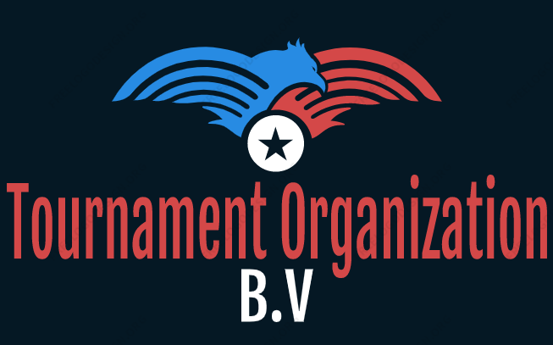

Our client is Mr. John Doe, he is the CEO of the company “Tournament Organization B.V.”, which is a company specialized in creating and managing tournaments.

# **TEAM**

ICT Software Solution

Represented by Renis Hila

Contact information: [r.hila@student.fontys.nl](mailto:r.hila@student.fontys.nl)

# **CURRENT SITUATION**

Tournament Organization B.V. is a company that specializes in creating and managing tournaments. At present, they are relying on manual methods to handle all aspects of their tournaments.

# **Problem Description**

The current manual management system is inefficient and prone to errors, leading to delays and mistakes. It requires a lot of time and effort to manage tournaments, teams, players, and other related elements.

# **PROJECT GOAL**

Our main objective is to develop a software solution that can streamline and automate Tournament Organization B.V.'s tournament management processes, making it easier and more efficient to create and manage tournaments, teams, players, and other related elements.

# **CONSTRAINTS**

1. **Time**

The project must be completed by 09/06/2023.

1. **Resources**

C# will be used for coding and MySQL for the database.

1. **Communication**

Regular weekly communication with the client is mandatory for successful project execution. These 15-20-minute sessions will serve to discuss project progress, address any concerns, gather feedback, and seek guidance.

# **Deliverables**

We are supplying the company:

* A desktop application
* A web application
* Documentation on how this was made

# **Non-Deliverables**

We are not supplying the company:

* With training manual
* Service and maintenance after delivering the application
* Hardware for the web application & desktop application

# **PHASING**

